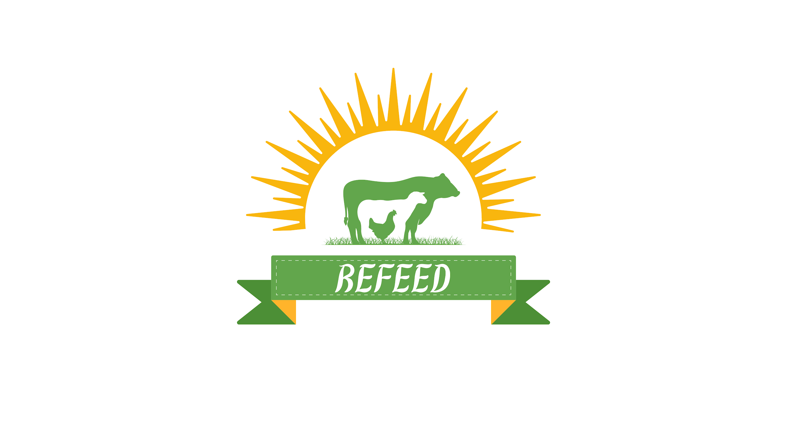

Developing a local feed manufacturing & production process

**Sep 28**

Document Status: Draft | **In Review** | Approved

**Executive Summary:**

**As a “Refeed” company mainly relay on importing goods, we are currently facing serious challenges due to the import crisis.**

**which has disrupted supply chains and increased costs.**

**In response to these issues, we are heading towards a self-sufficiency model.**

|  |
| --- |
| **Project Goal** |
| ***SMART: S****pecific,* ***M****easurable,* ***A****ttainable,* ***R****elevant, and* ***T****ime-bound*  Develop a feed production process that incorporates growing crops and using food waste as alternative for livestock.  **Goal one questions**  **What makes this goal specific? Does it provide enough detail to avoid ambiguity?**  ***Response***:   * Develop a feed production process that incorporates growing crops and using food waste as alternative for livestock .   **What makes this goal measurable? Does it include metrics to gauge success?**  ***Response***:   * Reduce reliance on imported feed ingredients by 85% within 18 months 5% per month. * Produce 100 tons of livestock feed monthly by the end of the second year. * Achieve a 50% reduction in production costs by integrating 15% food waste into feed formulations.   **What makes this goal attainable? Is it realistic given available time and resources?**  ***Response***:   * Secure partnerships with at least 10 local farms and food waste suppliers within the first 6 months. * Establish a feed production facility for Research and development and training capable of processing both crops and food waste within 12 months.   **What makes this goal relevant? Does it support project or business objectives?**  ***Response***:  This project aligns with the company’s goal of reducing dependence on imports, lowering production costs, and supporting Egypt's sustainability efforts by recycling food waste.  **What makes this goal time-bound? Does it include a timeline or deadline?**  ***Response***:   * The project will be completed within 18 months, with regular milestones (e.g., construction of facilities within 6 months, test and run within 12 months).   **Goal Two**  **SMART Goal Two:**  Training for Farmers and Employees to enhance our crops and our manufacturing.  **What makes this goal specific? Does it provide enough detail to avoid ambiguity?**  ***Response***:   * Implement a training program for farmers and employees on advanced agricultural technologies, sustainable farming practices, and the development of competitive seeds and feed products.   **What makes this goal measurable? Does it include metrics to gauge success?**  ***Response***:   * Train at least 100 farmers and 50 employees within the first 3 months.   Conduct 10 training workshops focusing on sustainable farming techniques and seed development by the end of year one.  **What makes this goal attainable? Is it realistic given available time and resources?**  ***Response***:   * Partner with agricultural experts, research institutes, and technology providers to deliver training sessions on sustainable agriculture and competitive product development.   **What makes this goal relevant? Does it support project or business objectives?**  ***Response***:   * This training will enhance the efficiency and sustainability of crop production, improve the quality of the feed, and keep the company competitive in the market.   **What makes this goal time-bound? Does it include a timeline or deadline?**  ***Response***:   * The training program will be fully implemented within 12 months, with workshops held every quarter and ongoing support offered throughout the project's timeline.     **OKRs**   * **Lower production costs by integrating food waste.** * Integrate at least 30% food waste in feed formulations by month 12. * Achieve a 20% reduction in feed production costs within the first 9 months and 50% by month 18. * Building a new app Within 6 months for selling our products and building a strong supply chain by enhancing it with the app and building a bridge between (hotels & restaurants... etc.) and Livestock farms by making (hotels, Restaurants ...etc.) send their food waste to the farms which need it for livestock. * Deliver 10 training workshops on agricultural technologies and sustainability by the end of year one. * Train 100 farmers and 50 employees within 12 months. * Implement sustainable seed development strategies within at least 50% of partner farms by the end of the project’s second year.  |  |  |  |  |  | | --- | --- | --- | --- | --- | |  | **O1** |  | **Set up feed production using crops and food waste.** |  | |  | KR1 |  | Secure 10 contracts with the best local crop suppliers and food waste partners within 5 months 2 contract per month. |  | |  | KR2 |  | Complete construction of feed production facilities within 6 months. |  | |  | KR3 |  | Start test production runs within 12 months with the best system in the market and achieve full-scale production by month 18. |  |  |  |  |  |  |  | | --- | --- | --- | --- | --- | |  | **O2** |  | **Reduce reliance on imported feed ingredients by 85%.** |  | |  | KR1 |  | Decrease the company’s reliance on imported feed materials by 40% within the first 9 months. |  | |  | KR2 |  | Reach 85% reduction in import dependency by project completion (18 months). |  | |  | KR3 |  | Building the most important Partnership with ministry of agriculture after 12 months. |  |  |  |  |  |  |  | | --- | --- | --- | --- | --- | |  | **O3** |  | **Lower production costs by integrating food waste.** |  | |  | KR1 |  | Integrate at least 15% recycled food waste in feed formulations by month 12. |  | |  | KR2 |  | Achieve a 20% reduction in feed production costs within the first 9 months and 50% by month 18. |  | |  | KR3 |  | Building a new app Within 6 months for selling our products and building a strong supply chain by enhancing it with the app and building a bridge between (hotels & restaurants ..etc) and Livestock farms By making ( hotels , Restaurants ...etc ) send their food waste to the farms which need it. |  |  |  |  |  |  |  | | --- | --- | --- | --- | --- | |  | **O4** |  | **Enhance knowledge of sustainable agricultural practices and seed development.** |  | |  | KR1 |  | Deliver the best 10 training workshops on agricultural technologies and sustainability by the end of year one. |  | |  | KR2 |  | Train 100 farmers and 50 employees to became the best within 3 months. |  | |  | KR3 |  | Implement The most efficient sustainable seed development strategies in at least 50% of partner farms by the end of the project’s in the second year. |  |  |  | | --- | | **Deliverables** | | 1. Feed Manufacturing Facility Construction   * Design and layout planning * Construction of the manufacturing facility * Installation of production machinery and quality control systems * Facility fully operational for feed production   2. Farm Setup and Crop Cultivation   * Acquire/lease land and install irrigation systems * Plant key crops (corn, soybeans, etc.) * Train farmers on sustainable agricultural practices * Farms ready for first harvest   3. Food Waste Collection and Processing System   * Establish partnerships with restaurants, hotels, and supermarkets * Set up food waste collection, transportation, and storage systems * Build processing units to convert food waste into feed ingredients * Achieve consistent food waste supply for feed production   4. R&D and Training Facility Establishment   * Design and build the R&D and training center * Hire agricultural scientists and training staff * Develop training programs on new agricultural technologies * Fully functional R&D and training center delivering sessions   5. App Development for Farm and Feed Management   * Design and develop app features (crop monitoring, feed orders, expert consultations) * Conduct testing with selected farmers * Launch the app and promote it to farmers and businesses * Achieve at least 1,000 downloads within three months |  |  | | --- | | **Business Case / Background** | | **Why are we doing this?**  As a Refeed company mainly relay on importing goods, we are currently facing serious challenges due to the import crisis,   * Effect   Customers frustration.  Due to the lack of feed a lot of Livestock will die.  Relying on other unhealthy feed sources.  Increasing of inflation rate of feed prices.   * Impact   Lack of our inventory.  Shortage of the company foreign currency.  Financial and Reputation losses  High demand.  Delays of supply chain.  Losing partners (farms & companies) due to the delays of the supply chain because of the feed shortage. |  |  | | --- | | **Benefits, Costs, and Budget** | | **Benefits:**   * Support new service leading to 5% revenue increase, reduce late shipments and related costs, increase customer satisfaction.   1. Reduced Dependence on Imports:  Resource: Local farmers and crop suppliers to provide raw materials, minimizing reliance on imported feed components.  2. Lower Production Costs:  Resource: Food waste suppliers (restaurants, hotels, supermarkets) who can consistently supply raw food waste for feed production, reducing input costs.  3. Environmentally Friendly Approach:  Resource: Sustainable farming technologies (e.g., drip irrigation, composting systems) to make your agriculture and feed production more eco-friendly.  4. New Revenue Streams:  Resource: Partnerships with livestock farms, food industry suppliers, and supermarkets, allowing diversified customer channels and stable revenue.  5. Competitive Advantage:  Resource: Training experts and agricultural consultants to teach employees and local farmers about new techniques and technologies.  6. Job Creation:  Resource: Hiring specialists for farming, R&D, manufacturing, logistics, and app development, helping generate jobs in rural areas.  Additional Benefits:  Export Potential:  Resource: Export licenses and agreements with foreign buyers and distributors to sell feed products to other countries.  Community Engagement:  Resource: Local partnerships with agricultural cooperatives and sustainability initiatives to enhance your company’s role in the community.  **Costs:**   * Price of software, installation fees, time spent on hiring and training.   1. Farm Development:  Resource: Agricultural land (200-300 acres), irrigation systems, farming tools, greenhouses, and laborers for planting and harvesting.  Estimated Cost: $900,000 - $1.3 million (based on land prices and farm setup costs from Sekem and Wadi Group in Egypt).  2. Feed Manufacturing Plant:  Resource: Machinery for processing food waste and crops into feed, manufacturing facility construction, and skilled operators for feed production.  Estimated Cost: $2.2 - $2.6 million (based on equipment and construction costs from Misr Feed Company).  3. Research & Development (R&D) Facility and Training:  Resource: Lab equipment, training rooms, and experts (agricultural scientists, feed specialists, trainers) to run R&D activities and train farmers.  Estimated Cost: $750,000 - $1.15 million (based on costs from Cargill and FAO training programs).  4. App Development:  Resource: App developers, UX/UI designers, product managers, and digital marketing professionals to build and promote the app.  Estimated Cost: $200,000 - $350,000 (based on digital platform costs from Vezeeta and Orcas).  5. Distribution Network:  Resource: Logistics providers, trucks, warehousing, packaging materials, and delivery staff to ensure the feed reaches customers.  Estimated Cost: $150,000 - $300,000 annually (based on logistics costs in Egypt from Wadi Group).  Additional Costs (Optional):  Marketing and Branding:  Resource: Marketing agency or in-house marketing team for brand building, advertising campaigns, and product education.  Estimated Cost: $50,000 - $150,000 annually (based on industry marketing costs for new product launches in Egypt).  Compliance and Certifications:  Resource: Consultants to obtain certifications (e.g., ISO, HACCP) and ensure compliance with local and international feed production standards.  Estimated Cost: $20,000 - $50,000 (one-time).  **Budget needed:**  Based on the milestones and resource requirements, here's a comprehensive budget:  1. Farm Setup:  Land acquisition, infrastructure (irrigation, tools, labor).  Total Cost: $900,000 - $1.3 million.  2. Feed Manufacturing Plant:  Machinery, construction, operational setup.  Total Cost: $2.2 - $2.6 million.  3. R&D Facility and Training:  Facility construction, staff recruitment, training development.  Total Cost: $750,000 - $1.15 million.  4. App Development:  App design, development, marketing.  Total Cost: $200,000 - $350,000.  5. Distribution Network:  Logistics, warehousing, packaging, delivery systems.  Annual Cost: $150,000 - $300,000.  Total Budget Estimate:  Initial Setup Costs (for farms, manufacturing, R&D, app development):  $4.05 million - $5.4 million.  Ongoing Operational Costs (for labor, materials, logistics):  $700,000 - $1 million per year. |   Historical Data and References:  Agriculture: Sekem and Wadi Group in Egypt for sustainable farm setup timelines and costs.  Feed Manufacturing: Misr Feed Company for plant setup and production processes.  R&D and Training: Cargill Egypt and FAO for R&D center and training program costs.  App Development: Vezeeta and Orcas for app development costs and timelines in Egypt.  Logistics: Wadi Group for logistics and distribution in Egypt.   |  | | --- | | **Scope and Exclusion** | | **In-Scope:**   * Feed Production Process Development * Cost Reduction Initiatives * Partnerships * Facility Establishment * Training and Workshops * Development of Technology Solutions * Sustainability Initiatives * Customer Service Standards and Delivery Processes   **Out-of-Scope:**   * Product Development * Vendor Contracts * Changes to Existing Products * Expansion Beyond Initial Partnerships * Non-Feed Related Projects |  |  | | --- | | **Project Team** | | * Chairman * CEO * CFO * Investors * Project Manager * Operation Manager * Research and Development Manager * IT manager * Supply chain manager * Farmers * Co-Farmers * Employees * Project manager |  |  | | --- | | **Measuring Success** | | **What is acceptable:**   1. Reduce reliance on imported feed ingredients by 85% within 18 months 5% per month. Produce 100 tons of livestock feed monthly by the end of the second year. Achieve a 50% reduction in production costs by integrating 15% food waste into feed formulations 2. The project will be completed within 18 months, with regular milestones (e.g., construction of facilities within 6 months, test and run within 12 months).      1. Train at least 100 farmers and 50 employees within the first 3 months.   Conduct 10 training workshops focusing on sustainable farming techniques and seed development by the end of year one.   1. The training program will be fully implemented within 12 months, with workshops held every quarter and ongoing support offered throughout the project's timeline. 2. Building a new app Within 6 months for selling our products and building a strong supply chain by enhancing it with the app and building a bridge between (hotels & restaurants ...etc.) and Livestock farms by making (hotels, Restaurants ...etc.) send their food waste to the farms which need it | |